**Introduction to Cisco Packet Tracer**

**LAB # 07**



**Spring 2022**

**CSE303L-Data Communication & Computer Network**

Submitted by: **Ashfaq Ahmad**

Registration No: **19PWCSE1795**

Class Section: **B**

“On my honor, as student of University of Engineering and Technology, I have neither given nor received unauthorized assistance on this academic work.”

Student Signature: ______________

Submitted to:

**Eng: Faizullah**

June 1, 2022

**Department of Computer Systems Engineering**

**University of Engineering and Technology, Peshawar**

**CSE 303L: Data Communication and Computer Networks**

|  |  |  |  |  |
| --- | --- | --- | --- | --- |
| **Demonstration of Concepts** | **Poor(Does not meet expectation (1))**  The student failed to demonstrate a clear understanding of the assignment concepts | **Fair(Meet Expectation (2-3))**  The student demonstrated a clear understanding of some of the assignment concepts | **Good (Exceeds Expectation (4-5)**  The student demonstrated a clear understanding of the assignment concepts | **Score**  **30%** |
| **Accuracy** | The student mis-configured enough network settings that the lab computer couldn't function properly on the network | The student configured enough network settings that the lab computer partially functioned on the network | The student configured the network settings that the lab computer fully functioned on the network | **30%** |
| **Following Directions** | The student clearly failed to follow the verbal and written instructions to successfully complete the lab | The student failed to follow the some of the verbal and written instructions to successfully complete all requirements of the lab | The student followed the verbal and written instructions to successfully complete requirements of the lab | **20%** |
| **Time Utilization** | The student failed to complete even part of the lab in the allotted amount of time | The student failed to complete the entire lab in the allotted amount of time | The student completed the lab in its entirety in the al | **20%** |

**Credit Hours:**

**Objective(s):**

* To know about Packet Tracer.
* To know how to install Packet Tracer.
* TO know how to make a network in Packet Tracer.

## Introduction

Cisco Packet Tracer is an innovative network simulation and visualization tool. This free software helps you to practice your network configuration and troubleshooting skills via your desktop computer or an Android or iOS based mobile device. Packet Tracer is available for both the Linux and Windows desktop environments.

With Packet Tracer you can choose to build a network from scratch, use a pre-built sample network, or complete classroom lab assignments. Packet Tracer allows you to easily explore how data traverses your network. Packet Tracer provides an easy way to design and build networks of varying sizes without expensive lab equipment.

**Task 01:** **Mention the downloading and installation steps with screenshots.**

Steps of Installation:

1. After **Cisco Packet Tracer download**, click on the downloaded exe file. Once below Window will appear, click the “Next” option –

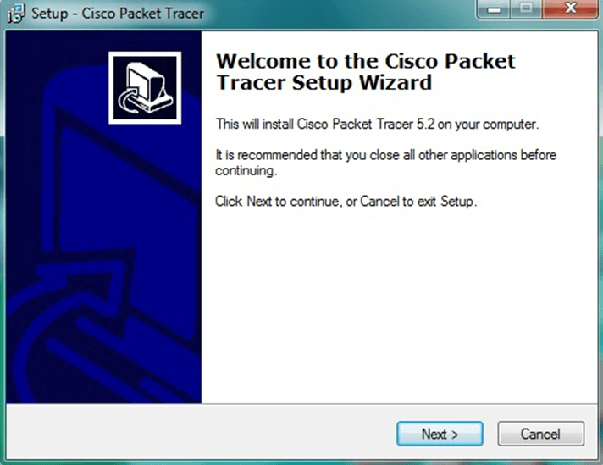

1. On the next screen, select “I accept the agreement” and click on “Next”.

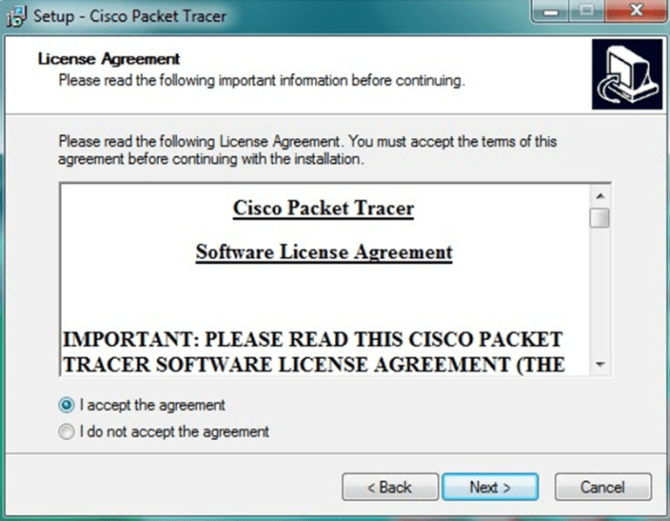

1. Setup will show the folder in which the program’s shortcuts will be created. If you want to change the folder, you can change it. Click on “Next”.

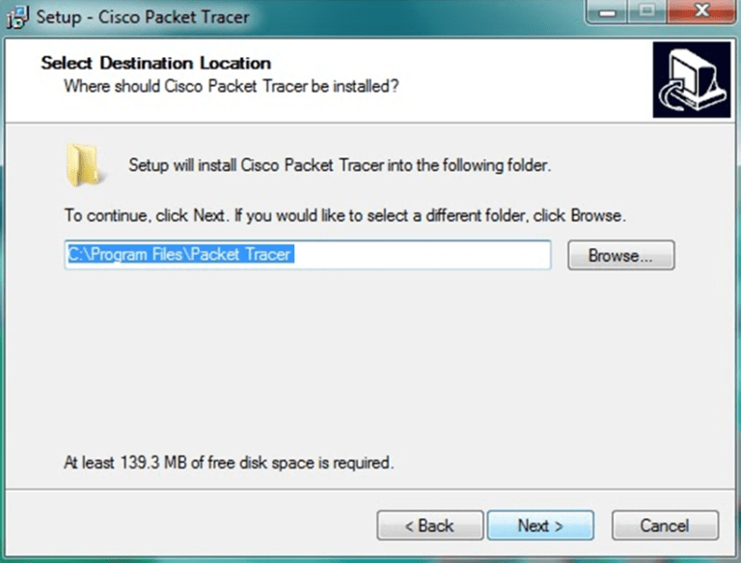

1. Then the program will ask whether to create a Desktop icon and create a Quick Launch icon. Make your choice and click on “Next”.

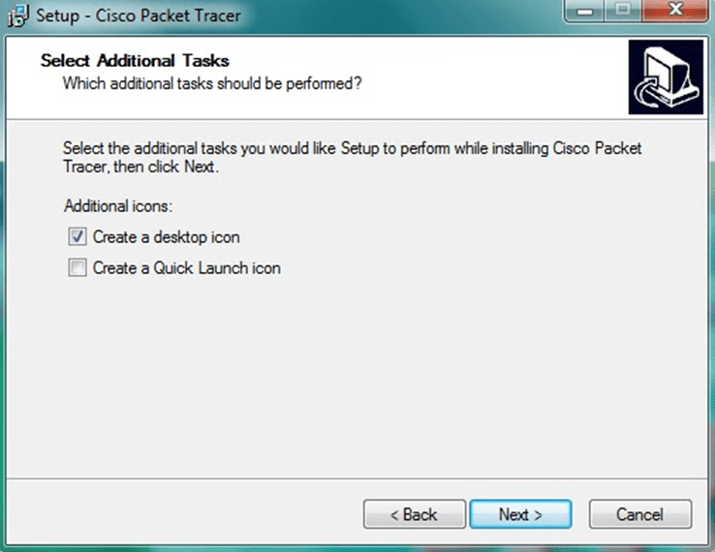

1. The summary of the settings we selected is displayed. Click on *“Install”*.

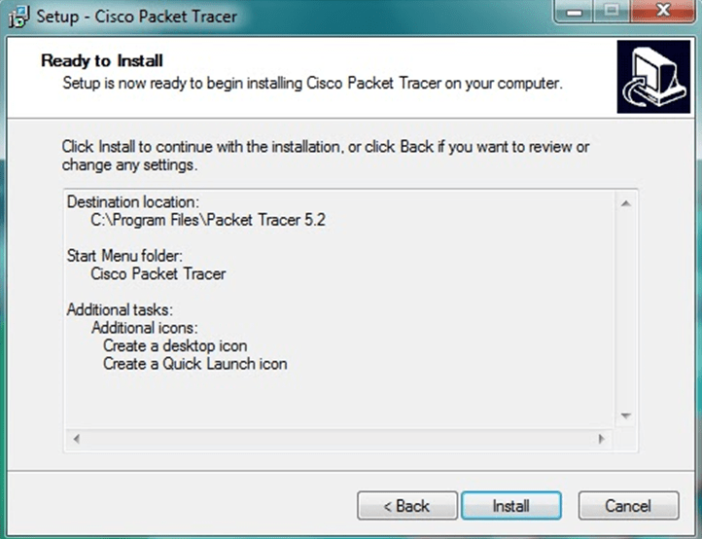

1. The cisco packet tracer installation starts as shown below.

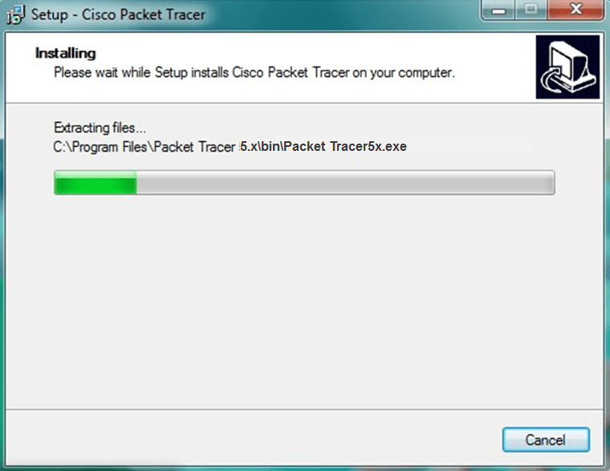

1. Cisco packet tracer Installation gets completed and the below screen is shown. Click on “Finish”. Click “OK” on next popup asking you to close or restart your computer.

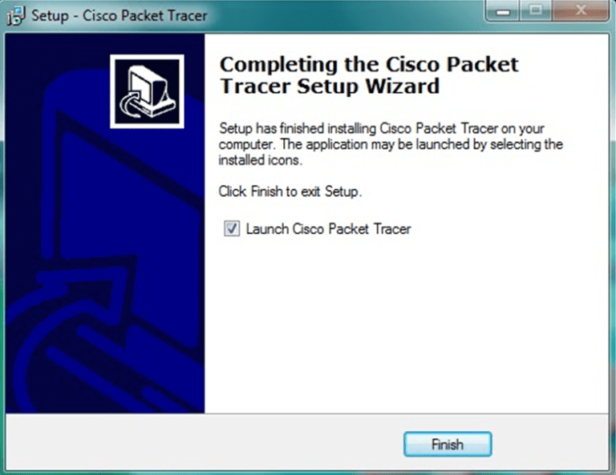

1. Packet Tracer is installed and ready to be used.

**Task 02: Make a simple connection between two end devices like PCs.**

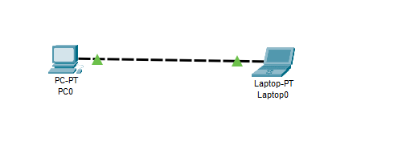

**Task 03: Check whether the two devices were able to communicate or not?**

* To check for communication first I assign IP address to both end devices and then I ping the IP of one PC in command window of other PC.

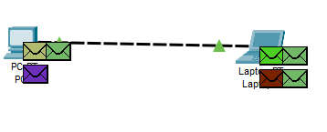

**Task 04:** **Which Ethernet cable did you use for the connection of two end devices?**

**Answer:** For same end devices connection we use copper cross-over cable.